|  |
| --- |
| **The One Stop Shop is a drop in where families can access support from**  **different services under**  **one roof.**  **We offer a warm welcome, refreshments, and an**  **opportunity to get help with:**  Housing  Finance  Accessing food banks  Mental health support  Emotional Health and Wellbeing  Relationship’s  Targeted Youth Support  Sexual Health  Substance / alcohol    … & more |



**Drop**

**-**

**in**

**2**

**nd Thursday of**

**every month**

**am till 12noon**

**9**

**@**

**Inspire Youth Zone**

**Chapel St**

**Chorley**

**PR7 1BS**

**Children and Family**

**Wellbeing Service**

**Tel:**

**01257 516 316**

**Email:**

**Chorleyfamilyhub@lancashire.gov.uk**

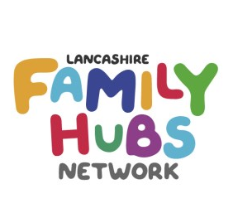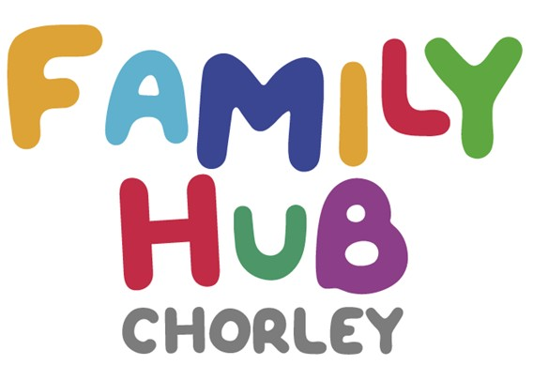

2

nd Thursday of



every month!

